a | b | c | d | e | f | g | h | i | j | k | l | m
 | x | x |  |  |  |  |  | x | x
Syllabus for B. Tech. III Year I semester
Computer Science and Engineering
WEB TECHNOLOGIES LAB
Code: 5FC82 L T P/D C
- - 4 2 Course Outcomes:
Implement programs using HTML tags , Java scripts along with along with Event Handling.Implement scripts using XML, DOM parser and SAX for project development. Also, the student should understand and implement the MVC architecture applications.
Course Outcomes:
After completing the subject, students will be able to 1. Describe WWW features and Demonstrate/ use of HTML tags
2. Develop dynamic programs involving Java scripts, popup windows in JavaScript along with Event Handling.
3. Develop scripts using XML and XSLT and to read XML document using parsers, DOM parser and SAX parser.
4. Develop Java servlets using Apache Tomcat Server for user authentications
5. Develop JDBC Application using JSP and ODBC Connectivity.
Hardware and Software required :
1. A working computer system with either Windows or Linux
2. A web browser either IE or firebox
3. Tomcat web server and Apache web server
4. XML editor like Altova Xml-spy [www.Altova.com/XMLSpy – free ] , Stylusstudio , etc.,
5. A database either Mysql or Oracle 6. JVM(Java virtual machine) must be installed on your system
6. JVM(Java virtual machine) must be installed on your system
Week-1:

Design the following static web pages required for an online book store web site.
1) HOME PAGE:
The static home page must contain three frames.

Top frame : Logo and the college name and links to Home page, Login page, Registration page,
Catalogue page and Cart page (the description of these pages will be given below).
Left frame : At least four links for navigation, which will display the catalogue of respective links.
For e.g.: When you click the link “CSE” the catalogue for CSE Books should be displayed in the Right frame.
Right frame: The pages to the links in the left frame must be loaded here. Initially this page contains description of the web site.
Logo | Web Site Name
Home | Login | Registration | Catalogue | Cart
CSE  ECE  EEE  CIVIL | Description of the Web Site
Fig 1.1

2) LOGIN PAGE:
This page looks like below:
Logo | Web Site Name
Home | Login | Registration | Catalogue | Cart
CSE  ECE  EEE  CIVIL | Login :  Submit  Reset  Password:

3) CATOLOGUE PAGE:
The catalogue page should contain the details of all the books available in the web site in a table.
The details should contain the following:
Snap shot of Cover Page.
Author Name.
Publisher.
Price.
Add to cart button.

Logo | Web Site Name
Home | Login |  | Registration | Catalogue |  | Cart
CSE  ECE  EEE  CIVIL |  | Book : XML Bible  Author : Winston  Publication : Wiely |  |  | $ 40.5
CSE  ECE  EEE  CIVIL |  | Book : AI  Author : S.Russel  Publication : Princeton hall |  |  | $ 63
CSE  ECE  EEE  CIVIL |  | Book : Java 2  Author : Watson  Publication : BPB publications |  |  | $ 35.5
CSE  ECE  EEE  CIVIL | 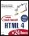 | Book : HTML in 24 hours  Author : Sam Peter  Sam publication |  |  | $ 50
Note: Week 2 contains the remaining pages and their description.

Week-2:
4) CART PAGE:
The cart page contains the details about the books which are added to the cart.
The cart page should look like this:
Logo | Web Site Name
Home | Login | Registration | Catalogue | Cart
CSE  ECE  EEE  CIVIL | Book name Price Quantity Amount  Java 2 $35.5 2 $70  XML bible $40.5 1 $40.5  Total amount - $130.5

5) REGISTRATION PAGE:
Create a “registration form “with the following fields
1) Name (Text field) 2) Password (password field) 3) E-mail id (text field)4) Phone number (text field) 5) Gender (radio button) 6) Date of birth (3 select boxes) 7) Languages known (check boxes – English, Telugu, Hindi, Tamil) 8) Address (text area)

WEEK 3:
VALIDATION:
- Write JavaScript to validate the fields of the above registration page.
Create the internal stylesheet using the following properties:
  - Apply font-family for all input and tr selectors- as Monotype Corsiva with font-size:30, color:brown, text-align: center
  - Use the following properties for option and select selectors with font-size:24 and color:blue
Write an internal javascript to validate fields of the registration form with the conditions:
- Name field - must not be null, - must have only alphabets, - size must not be greater than 45 characters, - must not have special characters apart from spaces.
- Password field - must not be null, - size must not be less than 6 characters, - must be combination of digits, special characters and alphabets.
- Email field - must not be null, - first character should be an alphabet,-must follow standard format: name@domain.com
- Phone Number field – must not be null, - must have exactly 10 digits, - must not have either the special characters or alphabets.
- Gender field – values must be Male, Female and Transgender, user must select only one.
- Date of Birth (DOB) field – must be 3 select boxes (DD, MONTH, YYYY). Else create the calendar for DOB selection.
- Languages known – values must be English, Telugu, Hindi, Tamil, etc, - user must be able to select known languages.
- Address field- should be a box of 5 rows and 50 columns, -must not be empty.

Do the following:
- Design the above mentioned fields: (Name, Password, Email, Phone Number, Gender, DOB, Languages Known and Address).
- All should be under one form with the appropriate attributes of form.
- Above field must be neatly aligned using the table tag.
- Place the buttons:
      - Submit- On clicking submit, validation function must execute.
      - Reset- All field must be cleared of the contents.
Note: Students can make use of the different events to validate the fields.
- Write a java script for statements.
- Java script to practice various events.
- JavaScript to practice the objects of JavaScript.
- JavaScript for alert boxes.
- JavaScript for functions.
- JavaScript for arithmetic operations, (calculator).

Week-4:
Design a web page using CSS (Cascading Style Sheets) which includes the following and also create the External CSS for the same and apply this to the earlier created web-pages.
1) Use different font, styles:
In the style definition you define how each selector should work (font, color etc.).
Then, in the body of your pages, you refer to these selectors to activate the styles.
2) Set a background image for both the page and single elements on the page. You can define the background image for the page like this:
BODY {background-image:url(myimage.gif);
3) Control the repetition of the image with the background-repeat property.
As background-repeat: repeat
Tiles the image until the entire page is filled, just like an ordinary background image in plain HTML.

4) Define styles for links as
A:link
A:visited
A:active
A:hover

5) Work with layers:

6) Add a customized cursor:
Selector {cursor:value}
Week-5:
Write an XML file which will display the Book information which includes the following:
1) Title of the book
2) Author Name
3) ISBN number
4) Publisher name
5) Edition
6) Price
- Write a Document Type Definition (DTD) or XML Schema Definition (XSD) to validate the above XML file.
- Display the XML file.
- The contents should be displayed in a table. The header of the table should be in color GREY. And the Author names column should be displayed in one color and should be capitalized and in bold. Use your own colors for remaining columns.
- Use XML schemas XSL and CSS for the above purpose.
Note: Give at least for 4 books. It should be valid syntactically.
Hint: You can use some xml editors like XML-spy
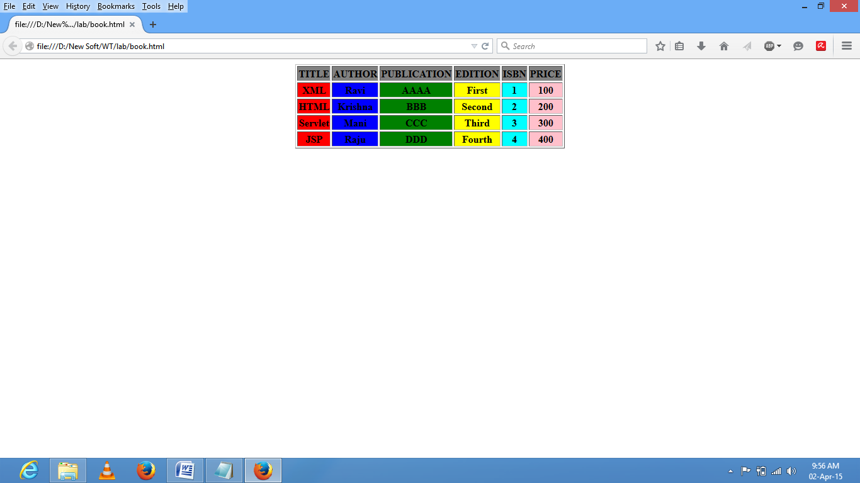

Week 6:
Install a database (Mysql or Oracle). And perform the following:
- Write a Java program to create a table using the fields of the Registration page created earlier in week 2 (program 5).
- Write a java program to connect to that database and experiment with various (select, insert, create, update, delete, retrieve etc) SQL queries. Also make use of Statement and PreparedStatement.
- Write a java program to call a procedure using the CallableStatement.
- Write jdbc program to get the metadata of the database table. Use MetaData.

Week-7:

- Install APACHE TOMCAT web server and while installation, assign port number 8181. Make sure that this port is available i.e., no other process is using this port.

- Access the above developed static web pages for books web site, using this server by putting the web pages developed in week-1 and week-2 in the document root. Access the pages by using the url : http://localhost:8181/rama/books.html.

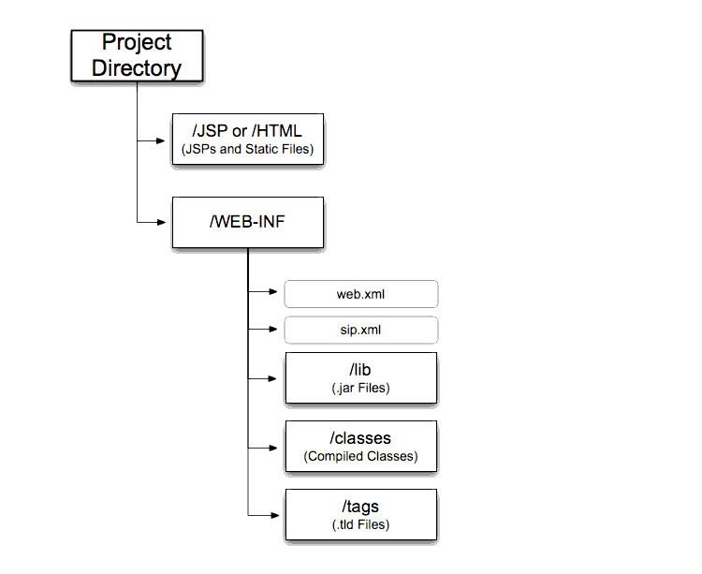
Figure 1 Directory structure for servlet

- Write a servlet program to print welcome message on the browser.(Files to be developed- java file, and deployment descriptor )
- Develop a web application to pass the parameters from the HTML page and display them using servlet.(Files to developed- Html,Java, Web.xml)
- Insert the details of the users who register with the web site, whenever a new user clicks the submit button in the registration page (week2) .(Files to be developed- Html,Java, Web.xml)
- Develop a web application using servlet to perform Create, Update, Retrieve and Delete (CURD) operations on the data in database from HTML form.(Files to be developed- Html,Java, Web.xml)
Note:
- if you are using Http-Servlets, then extend class with HttpServlets and make use of respective service method - like doGet(),doPost() etc – with request and response objects of Http-Servlets-like(HttpServletRequest req, HttpServletResponse res)
- Make use of init-parameter and context-parameter with the requirement of your application.
- Make use of appropriate HTML file with your servlet application.

Week 8:
- Write a servlet to work with context-parameters and Init-parameters.
- Develop a web application using servlet to perform Session Tracking with hidden form fields, cookies and url-rewriting and http sessions. (Files to developed- Html,Java, Web.xml)
- Write a servlet using RequestDispatcher class. (Files to developed- Html,Java, Web.xml)

Week- 9:
Develop a web application using servlet to perform the user Authentication:
A. Assume four users user1, user2, user3 and user4 having the passwords pwd1, pwd2, pwd3 and pwd4 respectively. Write a servlet for doing the following:
1. Create a Cookie and add these four user id’s and passwords to this Cookie.
2. Read the user id and passwords entered in the Login form (week1) and authenticate with the values (user id and passwords) available in the cookies.
If he is a valid user(i.e., user-name and password match) you should welcome him by name(user-name) else you should display “ You are not an authenticated user “.
Use init-parameters to do this. Store the user-names and passwords in the webinf.xml and access them in the servlet by using the getInitParameters() method.

B. Authenticate the user when he submits the login form using the user name and password
from the database.

Week-10:
Write a JSP which does the following job:
- Program to print welcome message on the browser.
- Insert the details of the users who register with the web site, whenever a new user clicks the submit button in the registration page (week2).
- Develop a web application to perform Create, Update, Retrieve and Delete (CURD) operations on the data in database from HTML form.

Week-11:
Create tables in the database which contain the details of items (books in our case like Book name , Price, Quantity, Amount )) of each category. Modify your catalogue page (week 2) in such a way that you should connect to the database and extract data from the tables and display them in the catalogue page using JDBC.
Pseudo-code for beyond the syllabus programs
Week-12:
- Write a PHP to test the database connection
<?php
$servername = "localhost";
$username = "username";
$password = "password";
// Create connection
$conn = new mysqli($servername, $username, $password);
// Check connection
if ($conn->connect_error) {
die("Connection failed: " . $conn->connect_error);
}
echo "Connected successfully";
?>

- Write a PHP to create Database
<?php
$servername = "localhost";
$username = "username";
$password = "password";
// Create connection
$conn = new mysqli($servername, $username, $password);
// Check connection
if ($conn->connect_error) {
die("Connection failed: " . $conn->connect_error);
}
// Create database
$sql = "CREATE DATABASE myDB";
if ($conn->query($sql) === TRUE) {
echo "Database created successfully";
} else {
echo "Error creating database: " . $conn->error;
}
$conn->close();
?>

- Write a php to create Table (for Registration Page of Week-2)

<?php
$servername = "localhost";
$username = "username";
$password = "password";
$dbname = "myDB";
// Create connection
$conn = new mysqli($servername, $username, $password, $dbname);
// Check connection
if ($conn->connect_error) {
die("Connection failed: " . $conn->connect_error);
}
// sql to create table
$sql = "CREATE TABLE Registration(
id INT(6) UNSIGNED AUTO_INCREMENT PRIMARY KEY,
firstname VARCHAR(30) NOT NULL, Phone_no number(30) NOT NULL,
email VARCHAR(50), gender varchar2(20), DOB date, Lang varchar2(20),
Address varchar2(40)
)";
if ($conn->query($sql) === TRUE) {
echo "Table MyGuests created successfully";
} else {
echo "Error creating table: " . $conn->error;
}
$conn->
close();
?>

Week 13:
- Write a PHP to insert values form HTML to database(registration Page)
HTML PAGE
<!DOCTYPE html>
<html lang="en">
<head>
<meta charset="UTF-8">
<title>Add Records Form</title>
</head>
<body>
<form action="insert.php" method="post">
<p>
<label for="firstName">First Name:</label>
<input type="text" name="first_name" id="firstName">
</p>
<p> <label for="phone_no">Phone number:</label>
<input type="text" name="ph_no" id="ph_no"> </p>
<p> <label for="emailAddress">Email Address:</label>
<input type="text" name="email" id="emailAddress"> </p>
<p> <label for="gender">Gender:</label>
<input type="text" name="gender" id="genderder"> </p>
<p>
<label for="Address">Address:</label>
<input type="text" name="address" id="Address">
</p>
<p>
<label for="DOB">DOB:</label>
<input type="text" name="dob" id="dob">
</p>
<p>
<label for="Language">Language Known:</label>
<input type="text" name="lang" id="lang">
</p>

<input type="submit" value="Add Records">
</form>
</body>
</html>

PHP to insert values
<?php
$link = mysqli_connect("localhost", "username", "password", "demo");
// Check connection
if($link === false){
die("ERROR: Could not connect. " . mysqli_connect_error());
}
//Fetching values form html
$first_name = mysqli_real_escape_string($link, $_REQUEST['first_name']);
$phone_no = mysqli_real_escape_string($link, $_REQUEST['phone_no']);
$email = mysqli_real_escape_string($link, $_REQUEST['email']);
$gender = mysqli_real_escape_string($link, $_REQUEST['gender']);
$address = mysqli_real_escape_string($link, $_REQUEST['address']);
$dob = mysqli_real_escape_string($link, $_REQUEST['dob']);
$lang = mysqli_real_escape_string($link, $_REQUEST['lang']);
// attempt insert query execution
$sql = "INSERT INTO registration VALUES ('$first_name', '$phone_no', '$email','$gender','$address','$dob','$lang')";
if(mysqli_query($link, $sql)){
echo "Records added successfully.";
} else{
echo "ERROR: Could not able to execute $sql. " . mysqli_error($link);
}
// close connection
mysqli_close($link);
?>

- Write a PHP to select values form database table.

<?php
$link = mysqli_connect("localhost", "username", "password", "demo");
// Check connection
if($link === false){
die("ERROR: Could not connect. " . mysqli_connect_error());
}
// Attempt select query execution
$sql = "SELECT * FROM registration";
if($result = mysqli_query($link, $sql)){
if(mysqli_num_rows($result) > 0){
echo "<table>";echo "<tr>";echo "<th>id</th>";echo "<th>first_name</th>";
echo "<th>phone_no</th>";
echo "<th>email</th>";
echo "<th>gender</th>";
echo "<th>ADDRESS</th>";
echo "<th>Dob</th>";
echo "<th>lang</th>";
echo "</tr>";
while($row = mysqli_fetch_array($result)){
echo "<tr>";
echo "<td>" . $row['id'] . "</td>";
echo "<td>" . $row['first_name'] . "</td>";
echo "<td>" . $row['phone_no'] . "</td>";
echo "<td>" . $row['email'] . "</td>";
echo "<td>" . $row['gender'] . "</td>";
echo "<td>" . $row['address'] . "</td>";
echo "<td>" . $row['dob'] . "</td>";
echo "<td>" . $row['lang'] . "</td>";
echo "</tr>";
}
echo "</table>";
// Free result set
mysqli_free_result($result);
} else{
echo "No records matching your query were found.";
}
} else{
echo "ERROR: Could not able to execute $sql. " . mysqli_error($link);
}
// Close connection
mysqli_close($link);
?>
- Write a PHP to update existing records of a database table.
<?php
$link = mysqli_connect("localhost", "username", "password", "demo");
// Check connection
if($link === false){
die("ERROR: Could not connect. " . mysqli_connect_error());
}
// Attempt update query execution
$sql = "UPDATE registration SET email='xyz@abcdmail.com' WHERE id=1";
if(mysqli_query($link, $sql)){
echo "Records were updated successfully.";
} else {
echo "ERROR: Could not able to execute $sql. " . mysqli_error($link);}
// Close connection
mysqli_close($link);
?>
- Write a PHP to validate user login
a). <html>
<title>login page</title>

<form method="post" action="login.php">
Username:<input type="text" name="username" placeholder="Enter username"><br>
password:<input type="password" name="password" placeholder="Enter the password"><br>
<input type="submit" name="submit">
<input type="reset" name="reset">
</form>

</html>

b.)
<?php
$con=mysqli_connect('localhost','username','password','database');
if(isset_POSt['submit']){
$name=$_POST['username'];
$password=$_POST['password'];
$sql=mysqli_query("select name,password from table name where name=$name and password=$password");
$result=mysqli_query($con,$sql);
if(mysqli_num_rows($result)>0)
{
header("location: home.php"); }else { echo "login denied"; }}?>

